The below document and screenshot explains the way to create the BCON package for T24.

Loign into T24 with credential for classic.

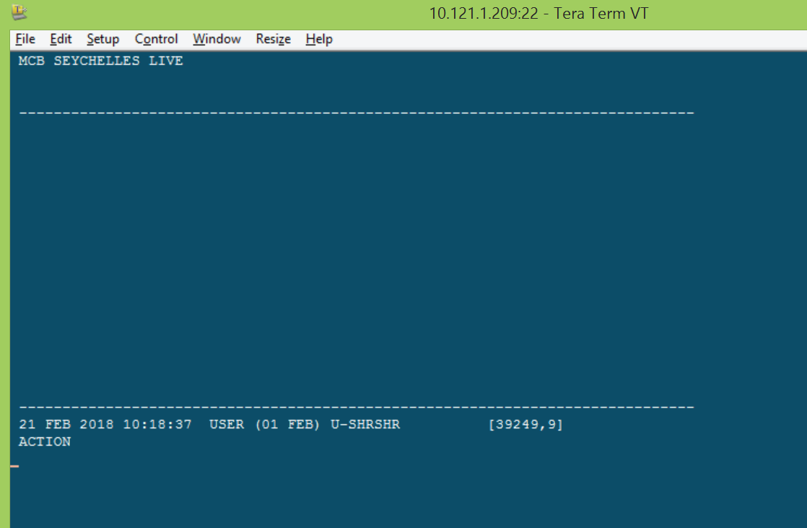

**HOW TO CREATE BCON PACK FOR PROD:-**

1. Check jshow for the subroutine which you are going to package. Note down the BP name. here PACS.BP

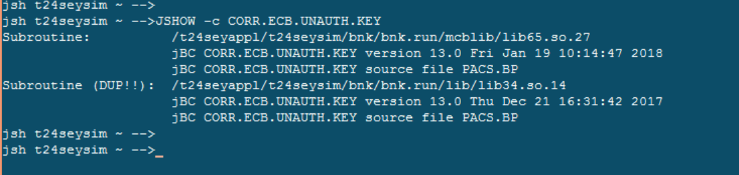

1. Enter BCON as shown below.

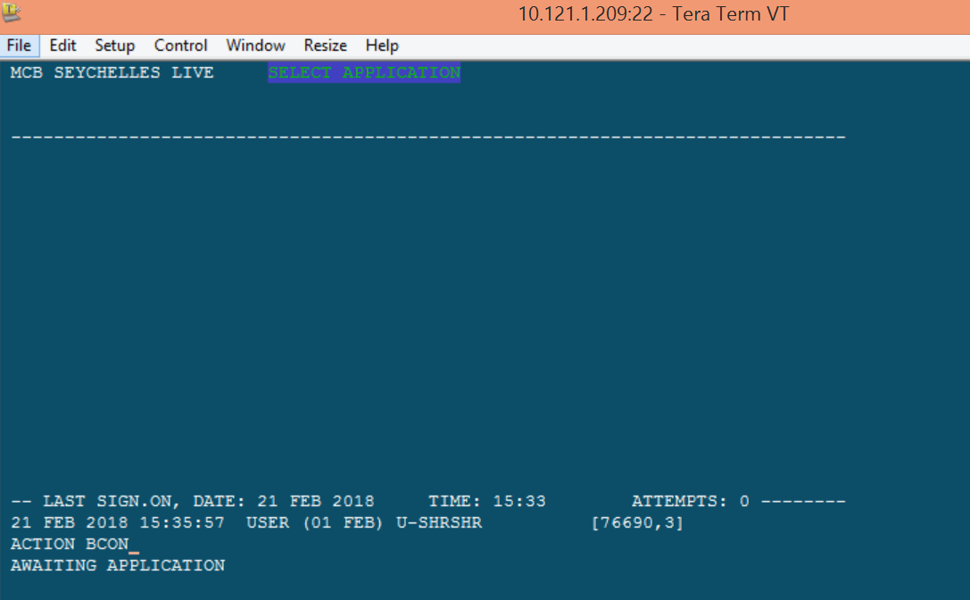

1. Give the package name with ticket reference. For eg here MCBS001-PACS00653987.SRC.V1

Then input the all mandatory fields as shown below.

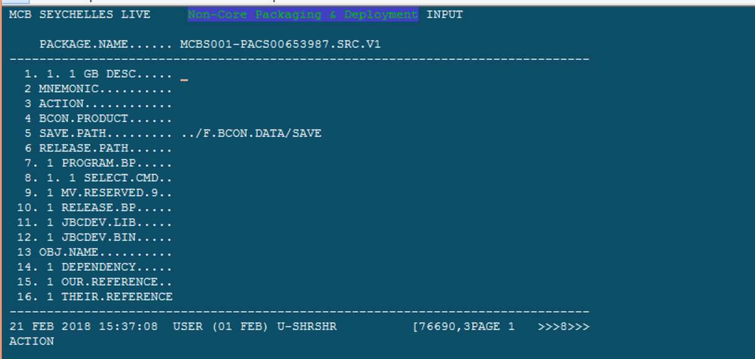

Input all values and commit the record.

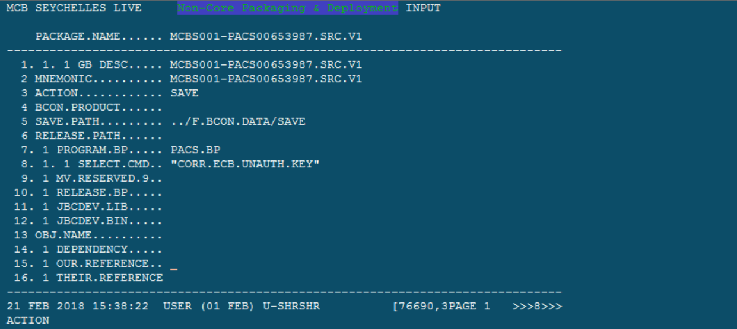

1. Verify the same record again. Use function **V** for the same.

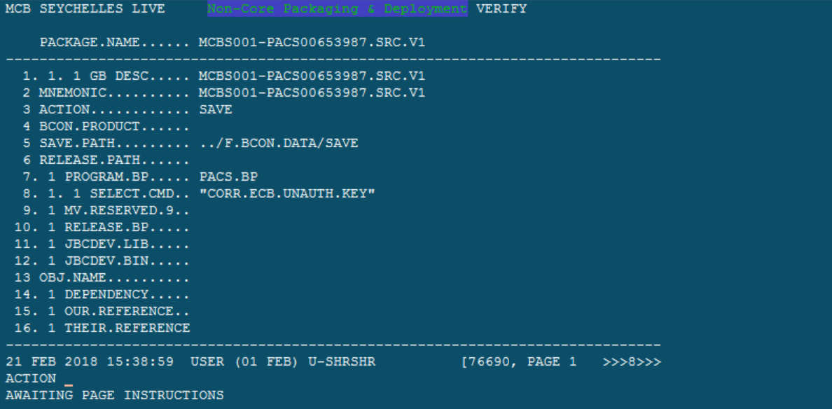

That’s it. Output will be saved in F.BCON.DATA/SAVE

**The below is same procedure as above. But it is for Source code Object package.**

1. Input all values as shown below and commit the record.

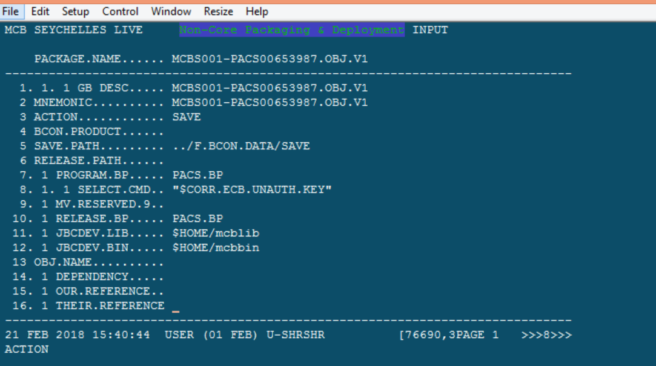

1. Verify the same record, so that output will be copied into F.BCON.DATA/SAVE

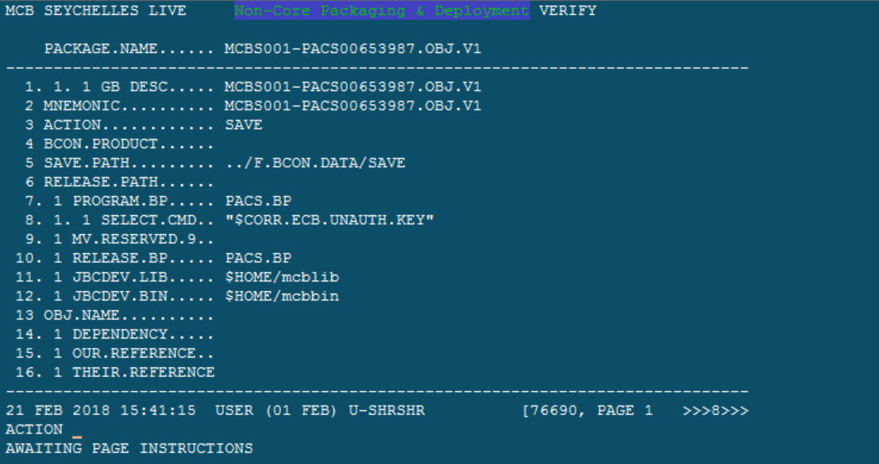

**Data Record package:-**

1. Open the DL.DEFINE application and create the record as shown below.

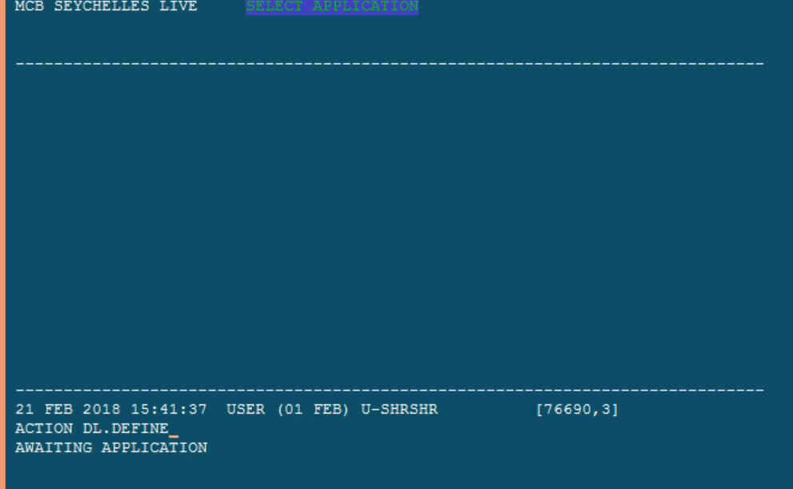

1. Give all your records by MULTI value the field FILE.NAME as per your no.of data records.

Here we have only one record PGM.FILE>CORR.ECB.UNAUTH.KEY.

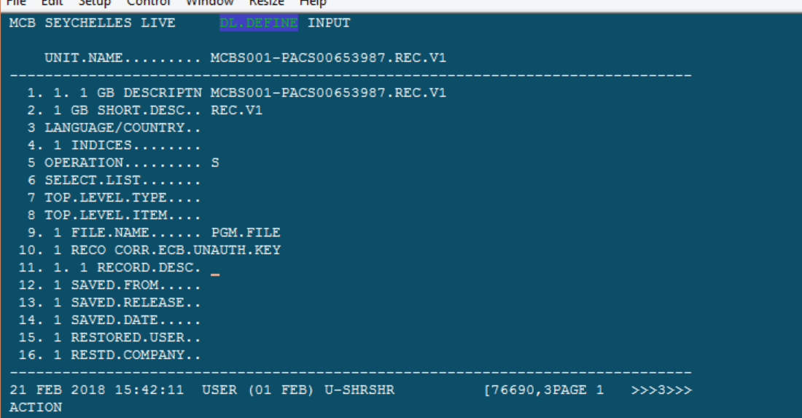

The below is record showing in SEE mode for your understanding.

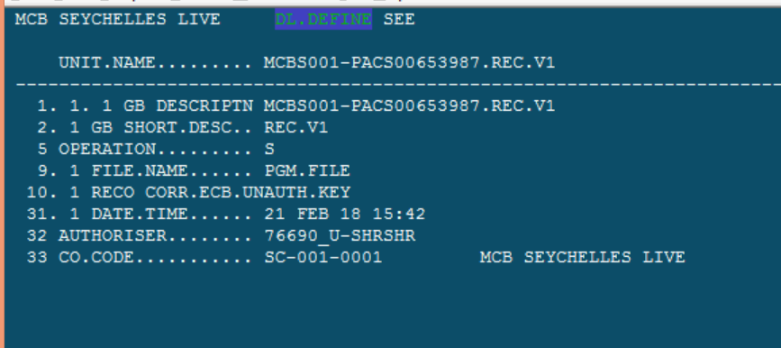

1. Now open the BCON application again and create the record as shown below. And then commit the record.

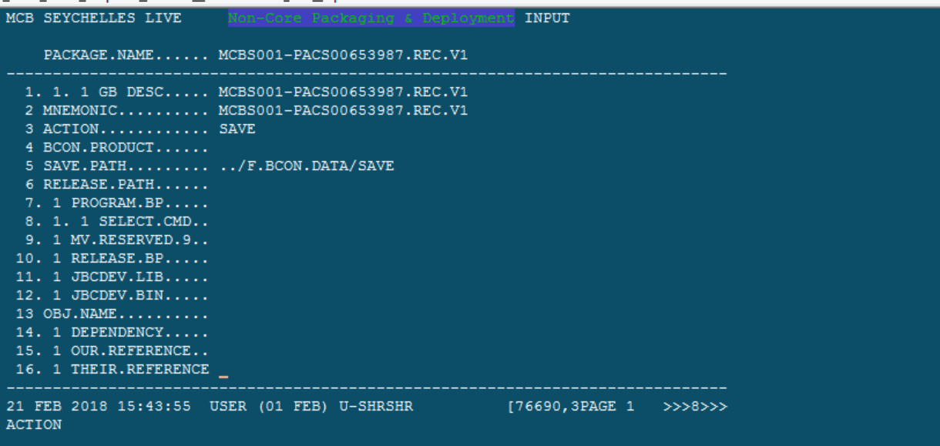

Note to input the DL.DEFINE field value as created above.

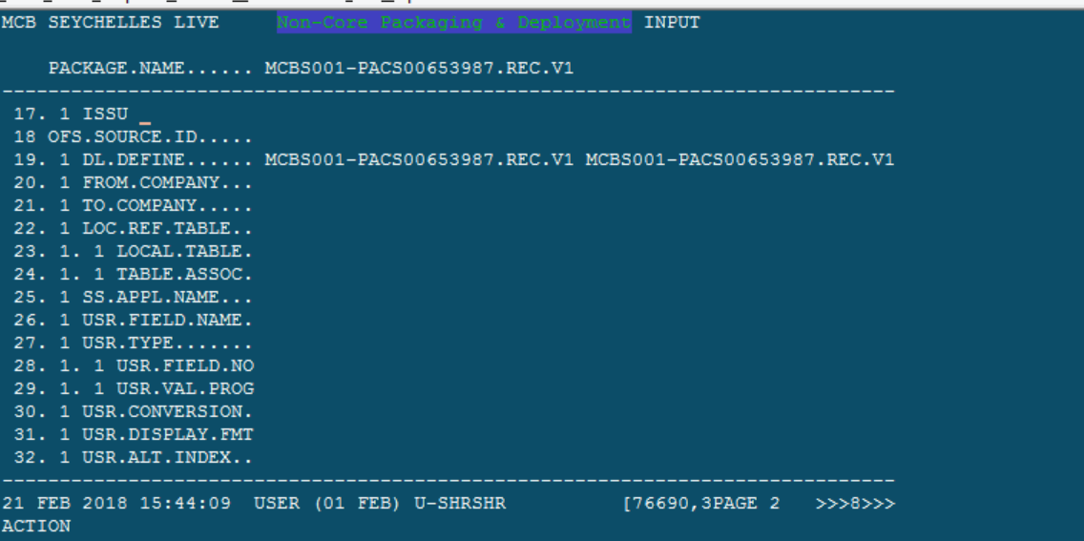

1. Verify the same record **MCBS001-PACS00653987.REC.V1**

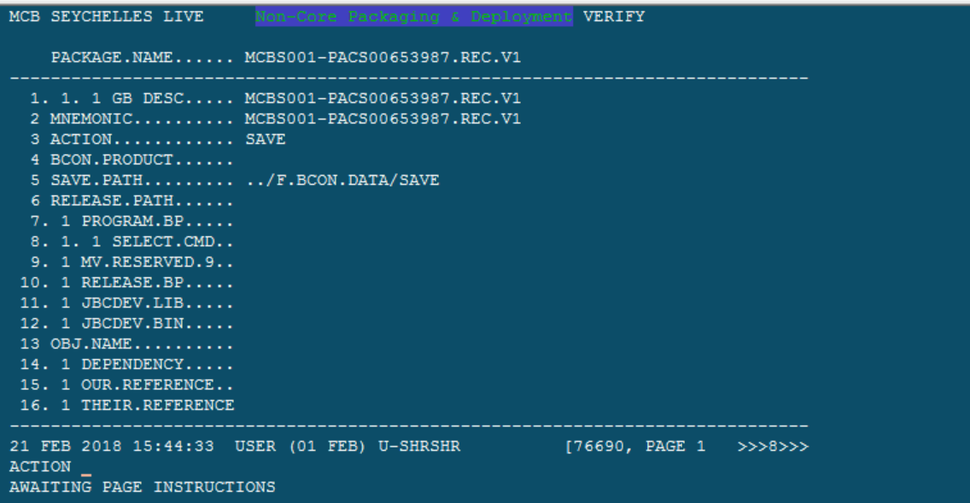

**Tar the package:-**

Navigate to the below path ../F.BCON.DATA/SAVE and use the below command to tar.gz the package**.**



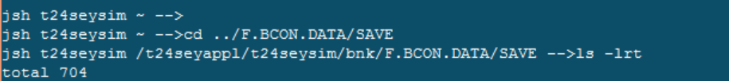

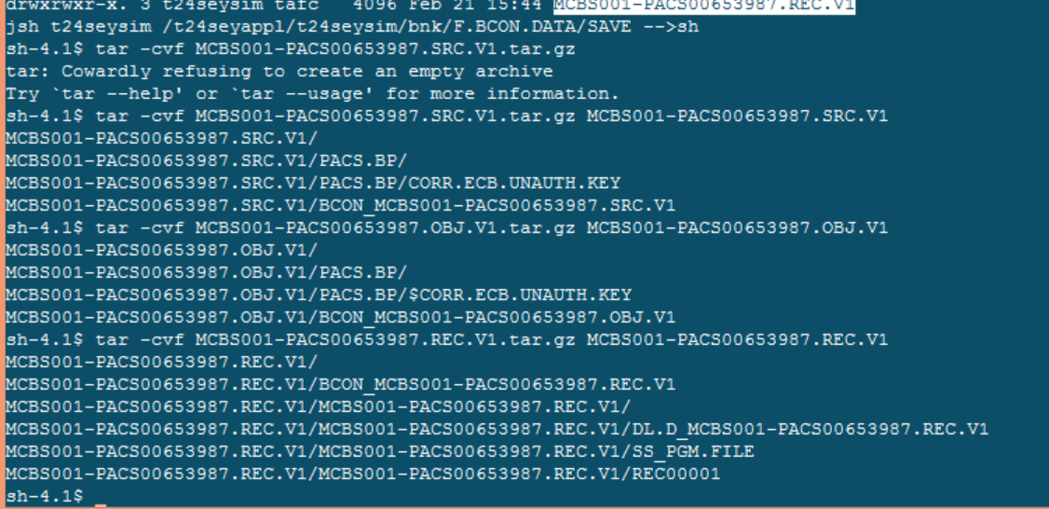

Download the package to your local disc.

